Problem Characteristics
An oil slick in radar images is a dark smudge on a noisy gray sea. Three things make it hard:
- It's tiny. In the data sample, the slick is 0.23% of the picture; about 1,800 pixels out of 800,000.
- It's thin. A few pixels wide. Squint and it's gone.
- Other things look identical. Calm patches of water, algae, and ship wakes all show up as dark smudges too. Telling them apart is the real job.
Every choice below comes from one of those three facts.
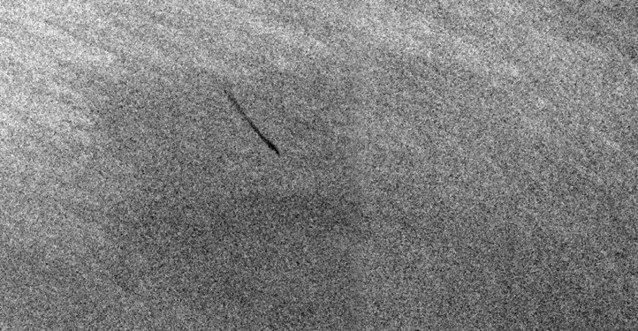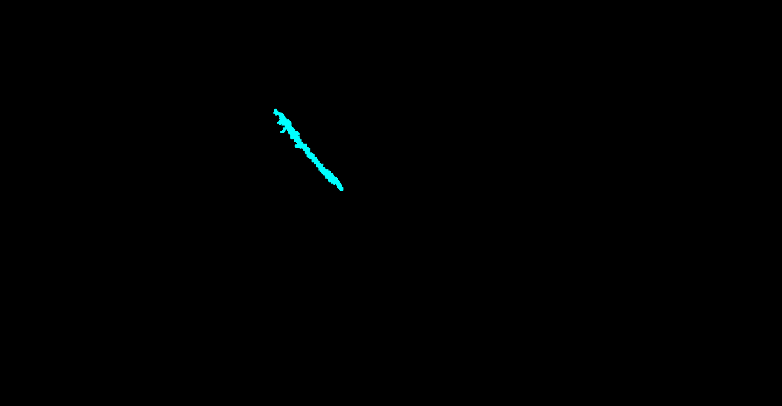

Why segmentation, not classification
A classifier allows to say if "there's oil in this picture."
Segmentation is capable to say: "the oil is exactly here, and it's this big."
Responders need the second one. That's why the whole field settled on segmentation, and it's why the dataset labels are painted masks rather than yes/no tags.

Why these models
The core issue: most models shrink the image before they analyze it. That's fine for spotting a cat. It's fatal for a 3-pixel-wide slick where it disappears in the shrinking. Therefore those models are suggested that either don't shrink much, or that have a side-channel to preserve fine detail.
Model | The plain reason it's here
DeepLabv3+ | It's what everyone else uses. We need it purely as a yardstick (benchmark); without it, nobody can tell whether your results are good
SegFormer | Built to keep fine detail all the way through. Best results for the least training time. Suggested pick
ViT-S + detail branch | The small, cheap model given out interest on Transformer based methods; but with an added side-channel that feeds it the fine detail it would otherwise lose. This is the version worth testing
ViT-S alone | The same model without the side-channel. Only worth running to prove the side-channel was necessary
DINOv2 | Learned from images without labels, which makes it unusually good when we don't have many labels either. Insurance in case your labelled set is small

Pipeline Stages
Stage 1: clean up. Raw radar images vary wildly in brightness depending on the satellite's angle and the weather. Standardizing that first matters more than which model you pick. Skipping it is the most common way these projects quietly fail.
Stage 2: find the slicks. This is the finetuning/training of the models from the table above. It's the actual work.
Stage 3: tidy the edges. Optional. Only worth it if you're reporting slick size to anyone, because on something this thin, sloppy edges make the size estimate badly wrong.

Three Important Settings
Zoom in before analyzing. Feed the model small patches blown up to double size, rather than whole images shrunk down. This is the single fix that makes the slick survive.
Score the model so that missing a slick hurts more than a false alarm. With 99.8% of the image being plain sea, a lazy model can score "99.8% correct" by finding nothing at all. We must actively penalize that.
Deliberately train on the look-alikes. Feed it calm water and algae labelled as not oil.
Our Dataset
- Images: 1250×650 px (fixed size, wide aspect ratio ~1.92:1),
- JPEG SAR imagery,
- 1002 train / 110 test samples.
Classes (from README.txt, labels_1D):
ID | Class | % of pixels | % of images containing it
0 | Sea Surface | 85.0% | 100%
1 | Oil Spill | 1.47% | 84%
2 | Look-alike | 10.2% | 50%
3 | Ship | 0.03% | 38%
4 | Land | 3.4% | 20%

Oil spill area (when present): mean 1.75%, median 0.61%, min 0.02%, max 13.95% of the image.
What this means for model choice
- Oil spill is a tiny, thin object class, not a dominant region; median 0.6% of pixels. At a naive 224×224 resize, that shrinks to only a handful of pixels, which a coarse-patch ViT (patch 16 → 14×14 tokens) can easily lose or blur into a single low-signal token.
- Dataset is small (1002 train images); training a large ViT from scratch will overfit badly; you need ImageNet-pretrained weights and/or a data-efficient variant.
- Look-alike (class 2) exists specifically to confuse with oil spill; the model needs enough local/textural resolution to discriminate, not just global attention.
- Labels are currently segmentation masks, not image-level labels; you'll need to derive a classification target (e.g., binary "oil spill present" = any pixel==1 in labels_1D, or multi-label over all 5 classes) before training a classifier.

Segmentation pipeline for ViT-S/16 (ImageNet-21k)

1. Architecture: ViT-S/16 encoder + lightweight upsampling decoder
ViT-S/16 has no native dense-prediction head (unlike DINOv2+DPT), so you need to attach one. Given only 1002 images, keep the decoder simple to limit overfitting risk — the SETR/Segmenter-style approach works well:
- Patch tokens (grid of H/16 × W/16) get reshaped back into a 2D feature map.
- A small progressive upsampling decoder (2–4 conv + transpose-conv/bilinear-upsample blocks, each roughly doubling resolution) maps that grid back to full input resolution, ending in a num_classes-channel conv.
- Avoid a heavy UperNet/DPT-style multi-scale decoder here — ViT-S/16 only gives you tokens from one resolution (no natural feature pyramid like a CNN backbone), so a simpler single-scale decoder is the appropriate match, not overkill.
2. Input preprocessing (resolution matched to patch16)
- Resize/pad 1250×650 → 1248×656 (both divisible by 16, aspect ratio 1.902 vs. original 1.923 — negligible distortion), giving a 78×41 token grid (3198 tokens).
- Normalize with ImageNet mean/std (matches ViT-S/16's ImageNet-21k pretraining stats).
- Augmentation: horizontal/vertical flip + mild rotation (SAR has no canonical orientation), light brightness/contrast jitter only — no aggressive color augmentation.
3. Target/classes
Use the 5-class labels_1D masks directly (Sea Surface / Oil Spill / Look-alike / Ship / Land) as multi-class segmentation targets — as discussed, keeping all 5 classes gives the model explicit contrastive signal against Look-alike, which is the main confusable class for Oil Spill.
4. Loss function (tuned to your measured class imbalance)
Combine:
- Class-weighted cross-entropy — weights inversely proportional to pixel frequency (Sea Surface 88.1%, Oil Spill 1.0%, Look-alike 5.6%, Ship 0.04%, Land 5.3%), capped to avoid instability from Ship's extreme rarity.
- Dice loss (per-class, averaged) — imbalance-robust, directly rewards correct overlap on small classes like Oil Spill and Ship.
- Total loss = CE_weighted + Dice (equal weighting is a reasonable starting point; tune if Oil Spill IoU lags).
5. Staged fine-tuning strategy (critical given 1002 images)
- Stage 1: freeze the entire ViT-S/16 encoder, train only the decoder head. Fast, low overfitting risk, establishes a baseline.
- Stage 2: unfreeze the last 2–4 transformer blocks, fine-tune end-to-end at a much lower LR (~10x smaller than the head LR). Only proceed here if Stage 1 underfits (encoder's generic ImageNet features aren't discriminating Oil Spill vs. Look-alike well enough).
6. Training configuration
- Optimizer: AdamW, weight decay ~0.01–0.05.
- LR: ~1e-3 for decoder-only (Stage 1), ~1e-5 for unfrozen encoder blocks (Stage 2), cosine decay with linear warmup (~5% of steps).
- Batch size: 4–8 (limited by 1248×656 resolution memory), use mixed precision (fp16/bf16).
- Epochs: 60–100 with early stopping on validation Oil Spill IoU (small dataset converges fast but benefits from patience).
- Train/val split: ~85/15, stratified so images with no oil spill (21% of the set) appear proportionally in both splits.
7. Evaluation metrics
- Per-class IoU/Dice, with Oil Spill IoU as the primary target metric — pixel accuracy is misleading here (88% background).
- Track Look-alike IoU alongside it as a proxy for false-positive leakage between the two visually similar classes.
- Mean IoU excluding background for a fairer overall signal.
8. Inference & post-processing
- Predict on the 1248×656 resized input, then resize logits/argmax back to native 1250×650.
- Given Oil Spill's low extent (0.48, thin/wispy shape), use only light morphological cleanup (small opening to remove 1–2px noise) — avoid closing operations that could merge or erase your dataset's average 2.6 disjoint spill blobs per image.

